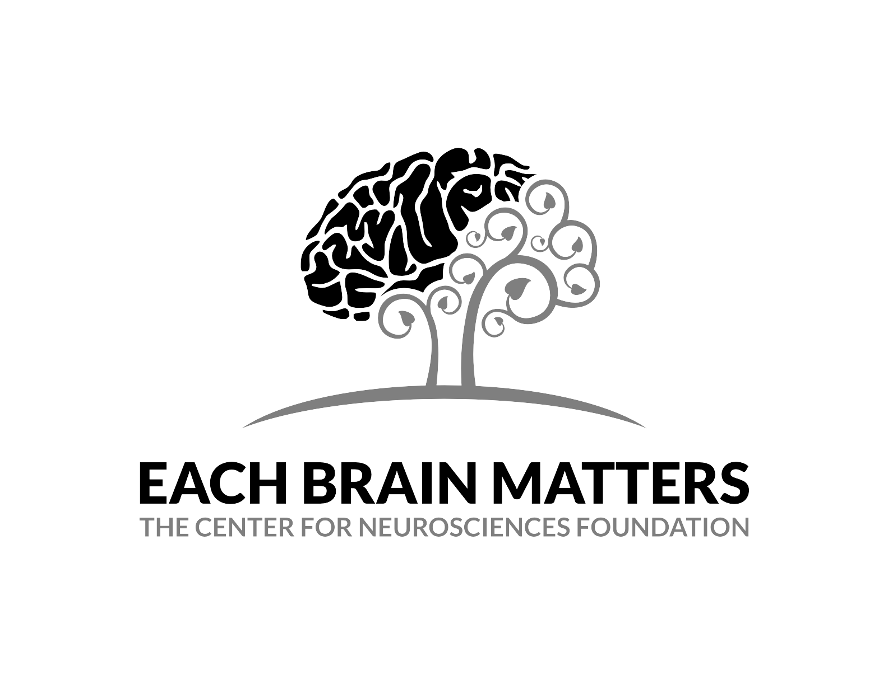
The Parts of the Brain and Their
Functions
Modified from Neuroscience for Kids
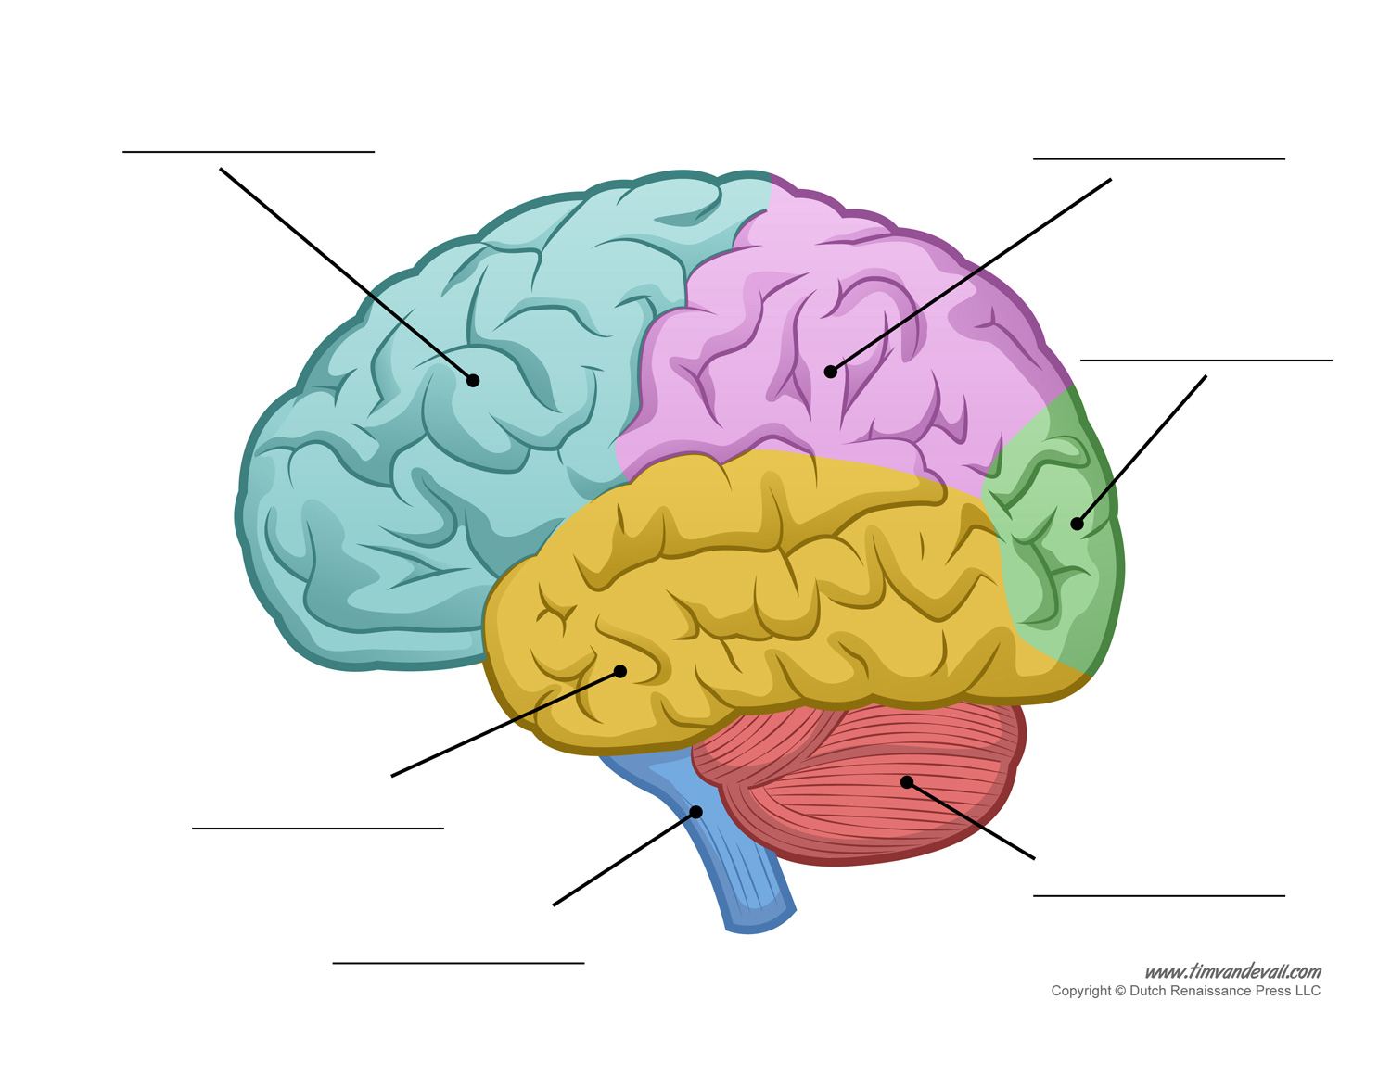

Cerebrum | The bulk of the brain matter, also called the cortex. It’s divided into 4 parts.
Cerebellum | This is Latin for “little brain” and therefore is the structure coming off of the back of the brain that looks a little like a smaller version of the brain.
Brain Stem | This portion sticks out from the bottom of the brain and connects to the spinal cord.
Frontal Lobe | This is part of the cerebrum and is located directly behind the forehead.
Parietal Lobe | This is part of the cerebrum and is located at the top of the head between the frontal and occipital lobes.
Temporal Lobes | This is part of the cerebrum at the sides; on each side, the temporal lobe extends in front of and behind the ears.
Occipital Lobe | This is part of the cerebrum and is at the very back of the head.

Now that you have correctly labelled the superficial (top) parts of the brain let’s find out what they do!

Cerebrum | The cerebrum performs the functions of all of the parts that make it up.
Cerebellum | This portion of the brain coordinates physical movement, posture, balance, and timing of movements. This means that it is involved in stopping and starting fine motor movements, like touching your nose. It also is involved in attention and language in ways we don’t understand well yet.
Brain Stem | This structure is made up of three other structures, the medulla, pons and the reticular formation. All together these structures regulate heartbeat, breathing, swallowing, sleep cycles, responses to stress, hunger and fullness.. These are all functions that are very important to life but are considered lower-level functions. This means that all vertebrate animals with brain have a brain stem because it helps keep them alive.
Frontal Lobe | Carries out higher mental processes such as thinking, decision making, and planning. These are called executive functions. The frontal lobe is also important in determining your personality. And, it is important in controlling behavior. At the back of the frontal lobe are motor control areas and the region that sends messages via your spinal cord to the muscles of your body.
Parietal Lobe | This lobe carries out many sensory functions, meaning that it allows you to experience your life as you know it. It gets information from the head and body about pain and temperature, and touch and pressure. It also is an area that brings together information from the various senses to form our perceptions of the world around us.
Temporal Lobe | You may have noticed above that a couple of senses were missing, one of which being hearing. The temporal lobe is responsible for processing auditory information from the ears. This lobe is involved in selective listening and allows you to detect different sounds being transmitted by sensors in your ears. That information is combined in the parietal lobe with information from the other senses.
Occipital Lobe | Another sense that we have yet to apply to a lobe is sight. And that is what the occipital lobe does. Visual information from the occipital lobe is sent to the temporal lobe and the parietal lobe where, in combination with information from the other sensory systems, the brain makes sense of what we see on a daily basis.

Fun fact!
Before we had the cool technology we do now, like MRI Machines or CAT scans, the way we found out what different parts of the brain did was through studying people who had injuries to their brain. Since each of these was done based on one person, they are called case studies, because you are studying one “case” or one person. And since what was being studied was an injury, they are also called lesion studies, because lesion is a fancy word that means a tissue or area in the body that has been injured. One of the most famous case studies was about a man named Phineas Gage.

- Phineas Gage was a man who worked on the railroad. One day
there was an accident when he was hammering one of the spikes down to tamp down the gunpowder deep in the hole. The metal bar made a spark, setting off a small explosion that threw the bar back at Phineas. It ended up going through his head! And looked like this: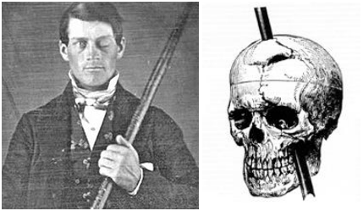 .
As you can see the spike only went through his frontal lobe, which is why when his personality started changing. From this lesion study, it was clear that the frontal lobe had something to do with personality.
It has since been confirmed by many studies that personality and many other executive functions are carried out by the frontal lobe.
Now that we have covered the parts of the brain directly underneath the skull, we can look a little deeper into the brain, especially at a family of structures that together form the limbic system. The limbic system is very important in memory, emotion, and motivation.

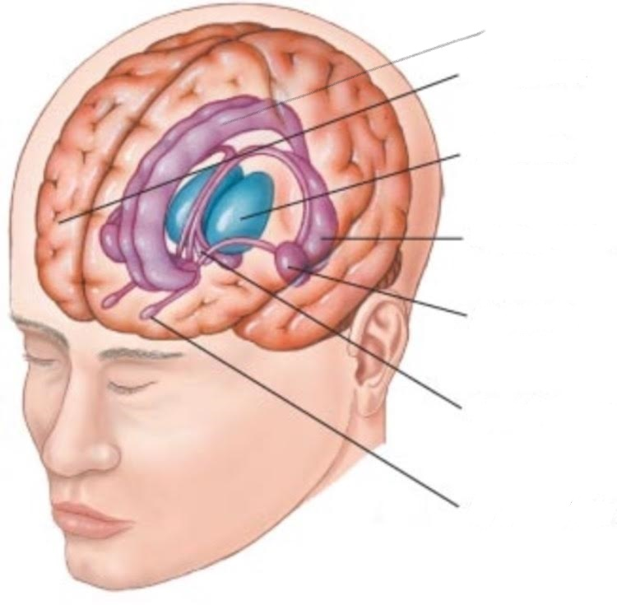
Amygdala | Amygdala means almond in Latin and therefore is an organ in the brain that has a shape like an almond. It is located deep in the temporal lobe.
Cingulate Gyrus | This is the part of the limbic system that is the largest and curves with the top curve of the brain.
Frontal Lobe | You know this one!!
Hippocampus | This is another curved part of the limbic system but instead of curving upward, it curves down in the temporal lobe and is connected to the amygdala.
Hypothalamus | These are structures just below the thalamus.
Olfactory Bulb | This small structures project (or stick out into) the frontal lobe.
Thalamus | This is the big egg-shaped structure in the middle of the limbic system.
Remember that the brain has two halves, so each of these structures is found on each side of the brain.

You know the drill, now that we have labelled these structures we can figure out what they do!

Amygdala | Plays an important part in emotions like fear and anger. And also in emotional memory!
Cingulate Gyrus | The cingulate cortex is involved in regulating emotions and the effect they have on your body, through controlling the chemicals your brain releases. It is also involved in encoding memories, especially emotional memories. It is also an important structure in decision making and externally focused attention (meaning paying attention in class!).
Frontal Lobe | You know this one!!
Hippocampus | The part of the brain that is responsible for making new short-term memories and then sending them to other places in the brain for storage as long-term memories. It is also important in our memories of the spaces around us so it is important in helping us navigate through the world.
Hypothalamus | The hypothalamus deals with motivation, as in it is linked to motivating you to get food when you are hungry. It has been shown that the lateral or side parts of the hypothalamus are involved with pleasure and rage.
Olfactory Bulb | Above we learned where major sensory centers are in the brain, like parietal lobe for touch, temporal for hearing, and occipital for sight. What sense is left? Smell! Smell sensors in your nose send information to the olfactory bulbs and information from the olfactory bulbs goes directly to certain parts of the limbic system that are involved in linking smell to memory. Can you think of any smells that remind you of a time or place?
Thalamus | The thalamus is very important to the whole brain, it is known as the central relay station for sensory information (except for smell).. What happens is most sensory signals go to the thalamus and then the thalamus directs these signals to the appropriate part of the brain to be processed further and combined to make sense of the world around us..

